**PROJECT REPORT**

**ESTIMATION OF BUSSINESS EXPENSES**

**1. INTRODUCTION**

**1.1 Overview:**

This report deal's into the fascinating realm of business expenses and provides a visual exploration of the various expenditures incurred by different businesses. It showcases the distribution of expenses, identifies key cost drivers, and highlights areas of potential optimization or concern. The visual representations allow for intuitive analysis, facilitating a deeper understanding of expenditure patterns and their implications for business performance. Decision-makers, financial analysts, and stakeholders can gain valuable insights into the financial health of businesses, identify areas of inefficiency or opportunity, and make informed decisions to optimize resources and drive growth. To Extract the Insights from the data and put the data in the form of visualizations, Dashboards and Story we employed Tableau tool.

**1.2 purpose:**

Estimation of business expenses is a crucial financial management practice that involves predicting and planning for the costs and expenditures a business is likely to incur in the future. This process is valuable for several reasons, and it can help businesses achieve various goals and objectives, including:

1. **Budgeting:** Estimating business expenses is fundamental to creating an accurate budget. By forecasting expenses, a business can allocate resources effectively, set financial goals, and ensure that it has enough funds to cover its costs.

2. **Financial Planning:** Accurate expense estimation is a critical component of long-term financial planning. It helps a business make informed decisions about investments, expansion, and debt management.

3. **Cost Control:** Estimation of expenses allows businesses to identify cost-saving opportunities. By knowing where the money is likely to be spent, a company can implement strategies to reduce costs and increase profitability.

4. **Pricing Strategies**: Understanding future expenses enables businesses to determine appropriate pricing strategies for their products or services. This ensures that the pricing is competitive and allows for a reasonable profit margin.

5. **Cash Flow Management:** By estimating expenses, a business can project its cash flow needs. This helps in managing working capital effectively, ensuring that there is enough cash on hand to cover expenses when they arise.

In summary, the estimation of business expenses is a fundamental financial management tool that contributes to the overall financial health and success of a business. It facilitates budgeting, financial planning, cost control, and effective decision-making. By predicting and managing expenses, businesses can enhance their financial stability, profitability, and competitiveness.

**2. PROBLEM DEFINITION AND DESIGN THINKING**

**2.1 Empathy Map:**

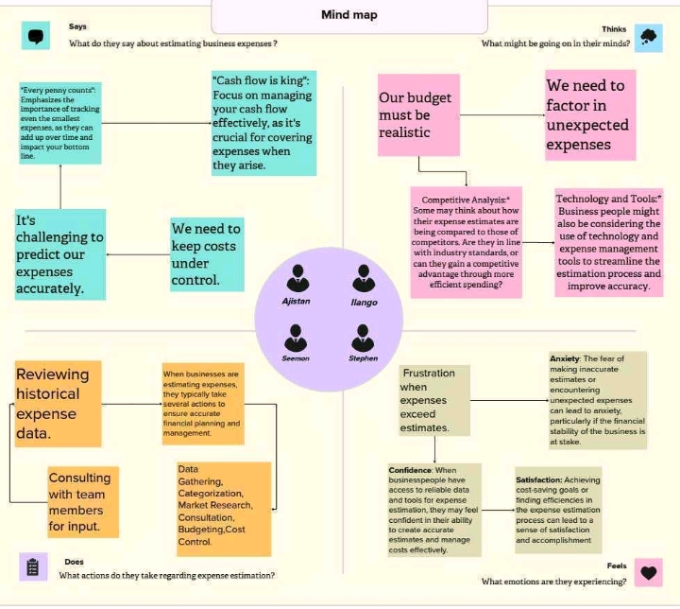

**2.2 Brainstorming Map:** 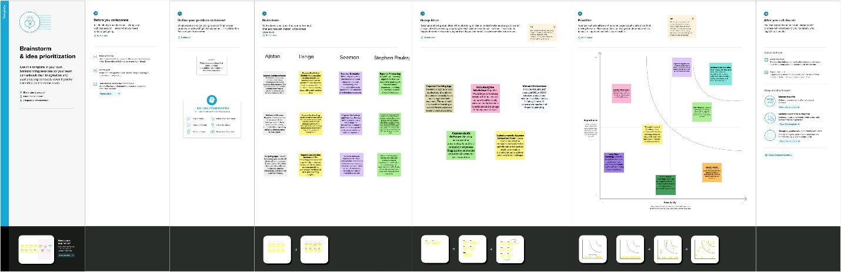

**3. Result:**

Estimating business expenses can vary greatly depending on the type of business, its size, industry, and location. To estimate business expenses, you typically need to consider various cost categories. Here's a general breakdown of expenses to consider when estimating business expenses:

1. **Operating Expenses:**
   * **Rent/Lease:** If you have a physical location, consider rent or lease costs for your office, storefront, or warehouse.
   * **Utilities:** Estimate costs for electricity, water, heating, and cooling.
   * **Office Supplies:** Include expenses for paper, pens, printer ink, and other office essentials.
   * **Insurance:** This includes liability insurance, property insurance, and workers' compensation.
   * **Maintenance and Repairs:** Budget for the upkeep of equipment and facilities.
2. **Employee-Related Expenses:**
   * **Salaries and Wages:**  Calculate the total compensation for your employees.
   * **Benefits:** Consider costs for healthcare, retirement plans, and other employee benefits.
   * **Taxes:** Include payroll taxes and other taxes related to employment.
3. **Cost of Goods Sold (COGS):**
   * **Inventory Costs:** Estimate expenses related to purchasing or producing your products or services.
4. **Marketing and Advertising:**
   * **Marketing Campaigns:** Include expenses for advertising, online marketing, and promotional materials.
   * **Website and SEO:** Budget for website maintenance and search engine optimization.
5. **Administrative Expenses:**
   * **Software and Technology:** Account for software licenses, subscriptions, and technology upgrades.
   * **Professional Services:** Budget for legal, accounting, and consulting fees.
   * **Travel and Entertainment:** Consider expenses related to business travel and client meetings.
   * **Office Equipment:** Include costs for computers, printers, and other equipment.
6. **Interest and Finance Charges:**
   * **Loan Interest:** If you have business loans, account for the interest payments.
7. **Taxes:**
   * **Income Tax:** Estimate your business income tax liability.
   * **Sales Tax:** If applicable, include sales tax collected from customers.
8. **Miscellaneous Expenses:**
   * **Unforeseen Costs:** Set aside funds for unexpected or emergency expenses.

To get an accurate estimate of your business expenses, it's essential to review your past financial records, create a detailed budget, and consider your future business plans and growth. Your business type, location, and industry will all influence the specific expenses you incur. Additionally, consulting with a financial advisor or accountant can help you refine your expense estimates and create a comprehensive budget.

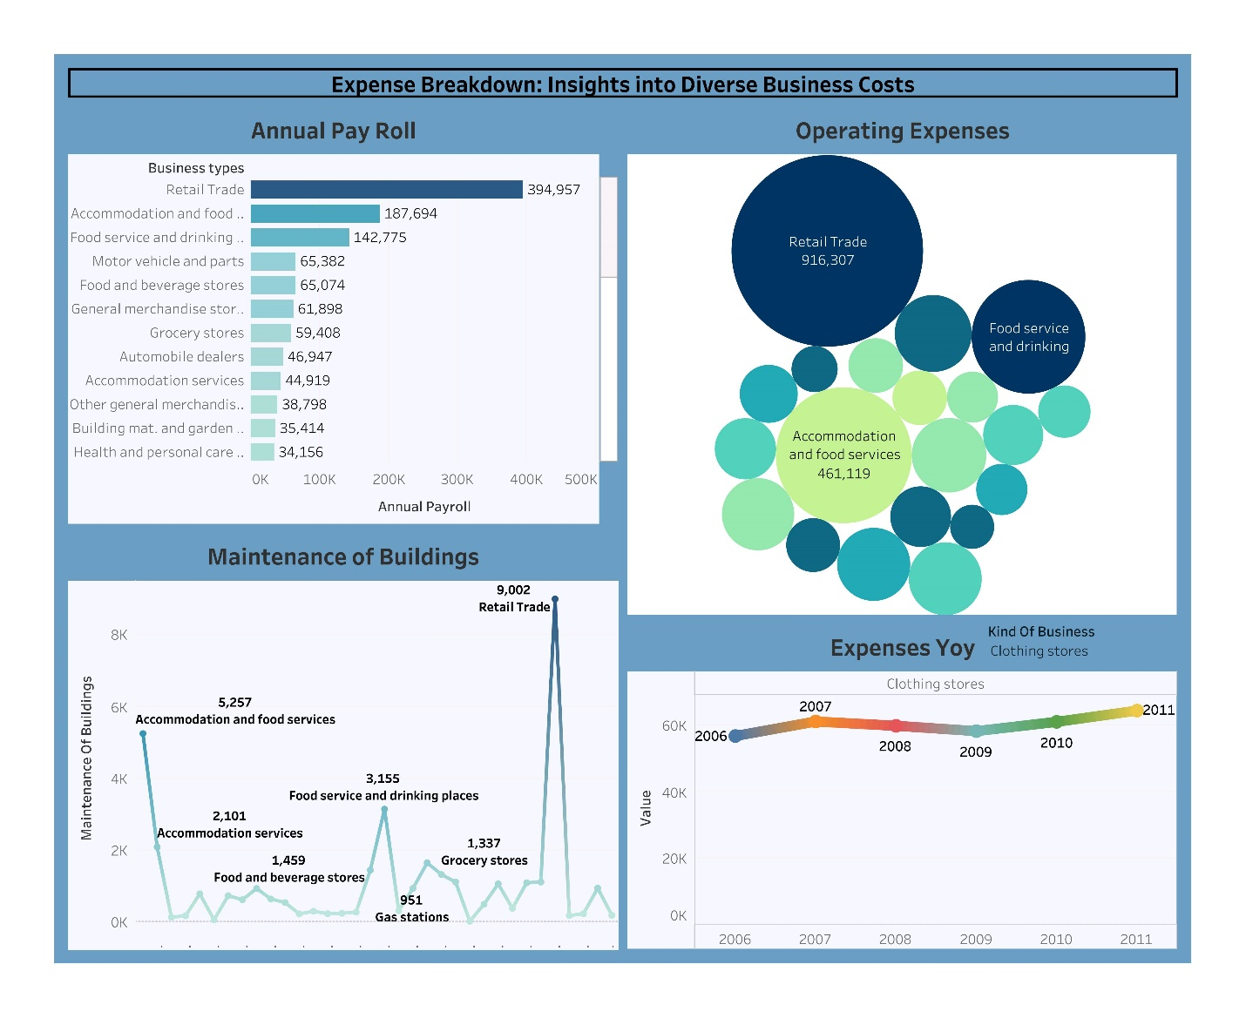

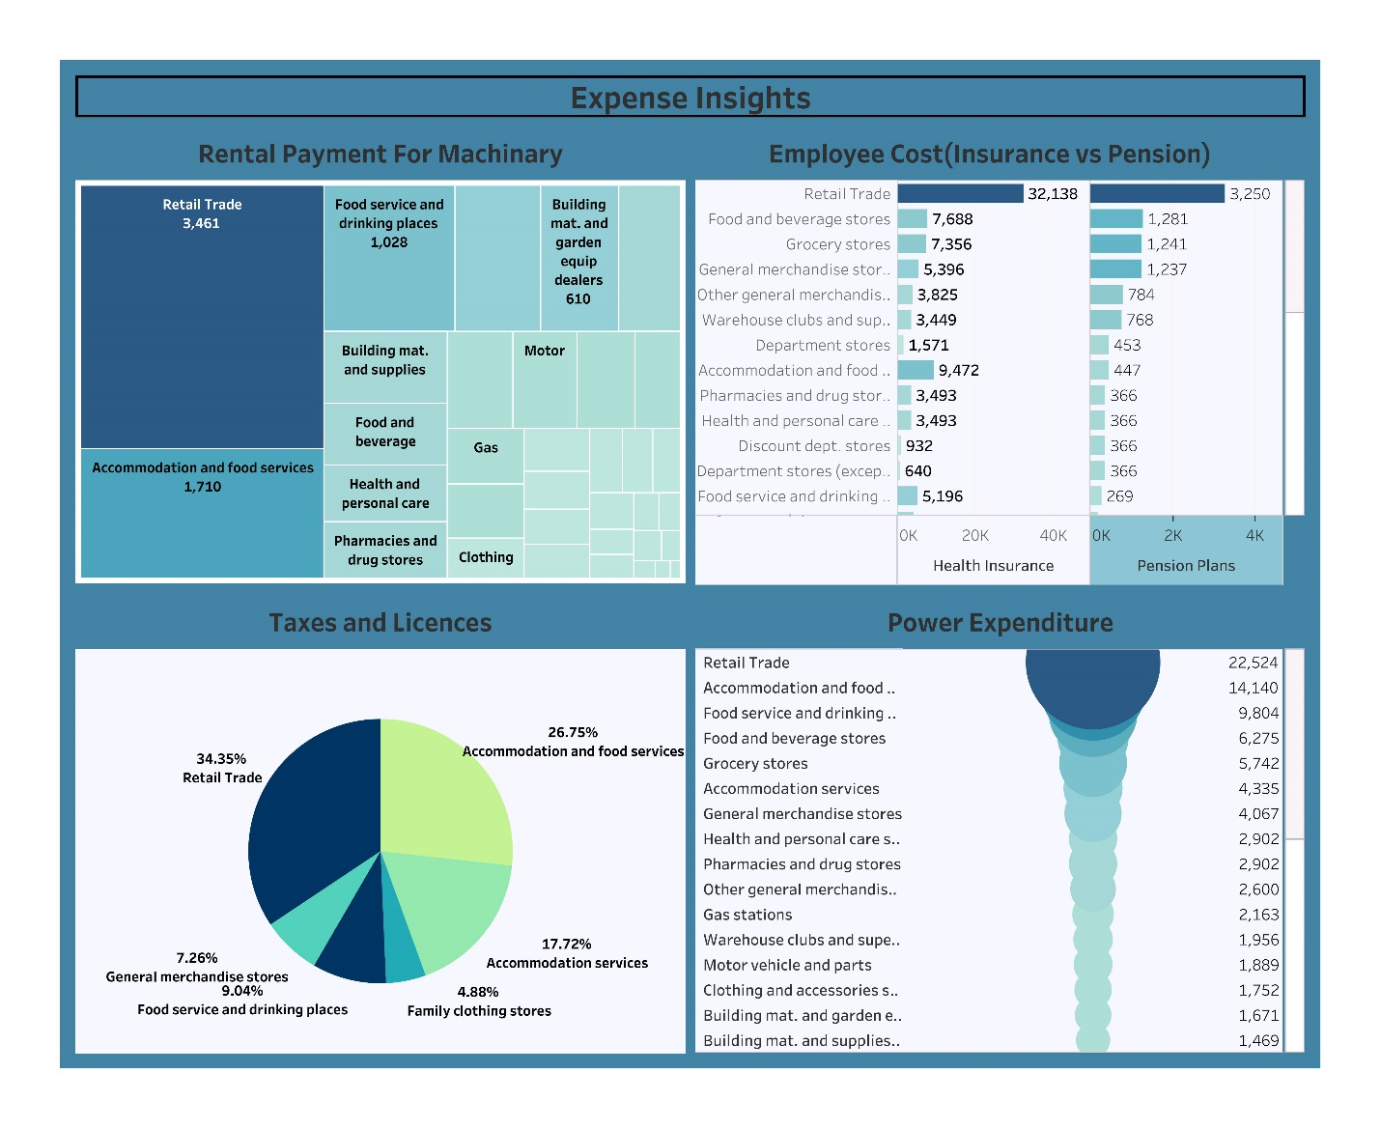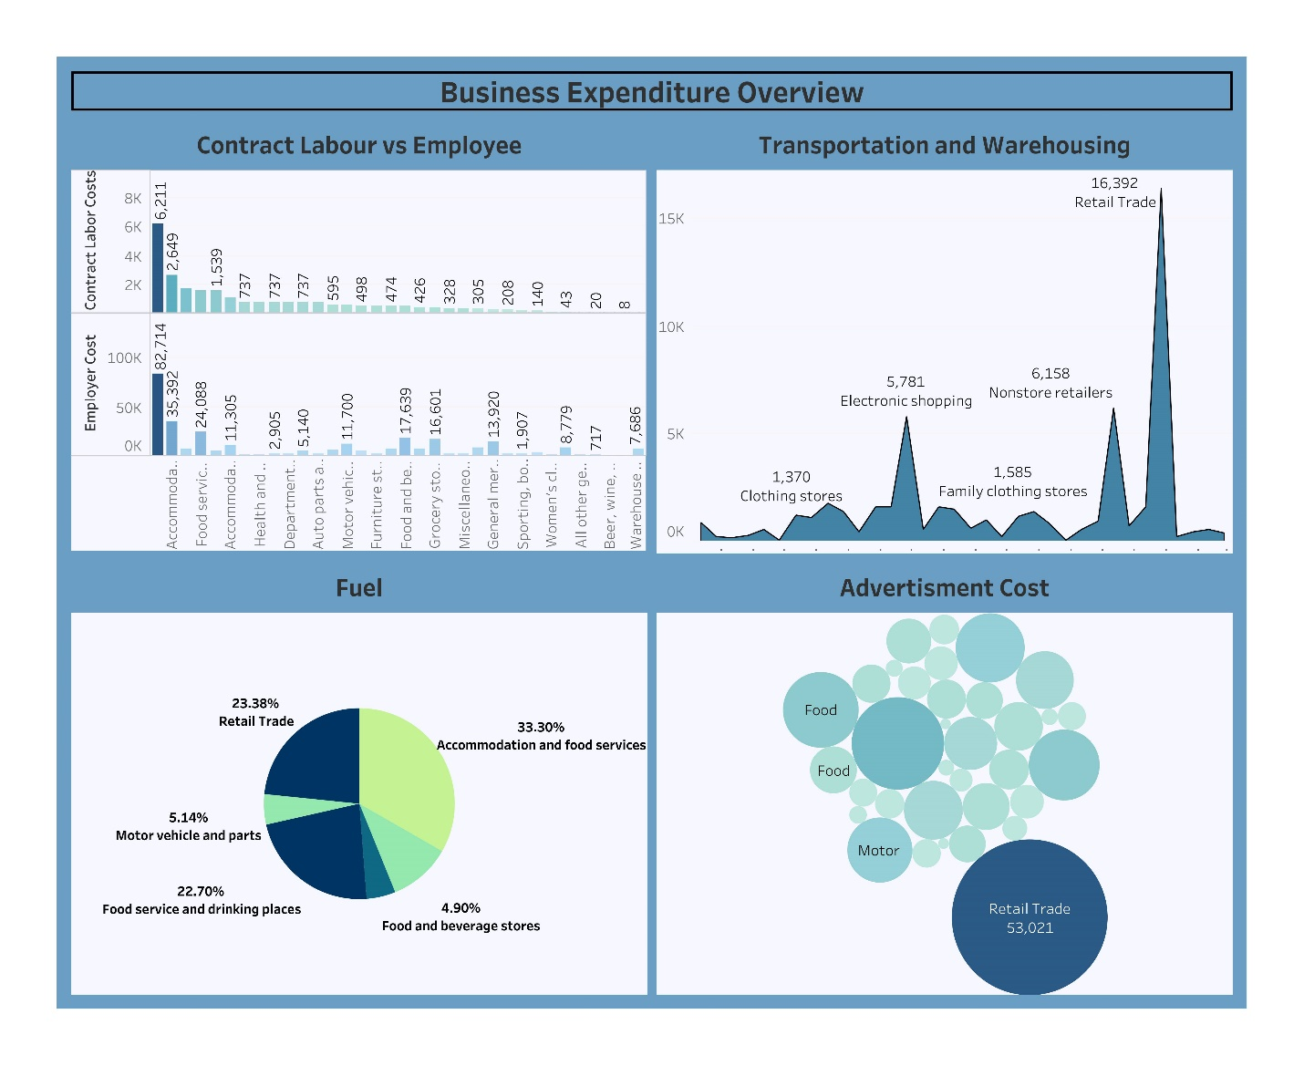

**4. ADVANTAGES AND DISADVANTAGES**

**4.1 Advantages:**

Estimating business expenses offers several advantages for businesses of all sizes and types. These advantages include:

1. **Financial Planning:** Accurate expense estimation is crucial for creating a comprehensive business budget. It allows you to plan for upcoming costs and allocate resources effectively. This, in turn, helps you make informed financial decisions.
2. **Cost Control:** By estimating expenses, you can identify areas where costs can be controlled or reduced. This can lead to more efficient operations and improved profitability.
3. **Cash Flow Management:** Knowing your expected expenses helps you manage cash flow more effectively. It ensures that you have sufficient funds to cover your financial obligations, such as paying bills and meeting payroll.
4. **Resource Allocation:** Expense estimation helps you allocate resources to different aspects of your business strategically. You can prioritize spending on areas that contribute most to your company's growth and success.
5. **Business Growth:** Understanding your expenses can aid in making decisions about business expansion or scaling down. It enables you to assess whether you can afford to take on new opportunities or need to cut back on certain expenditures.
6. **Pricing Strategies:** Accurate expense estimation is essential for setting competitive prices for your products or services. It ensures that you're covering your costs and achieving the desired profit margins.
7. **Investor Confidence:** If you seek external funding or investment, having a well-structured expense estimation demonstrates that you have a clear understanding of your business's financial health. This can instill confidence in potential investors.
8. **Tax Planning:** Proper expense estimation helps you plan for and manage your tax obligations. It ensures you're taking advantage of deductions and credits available to your business.
9. **Risk Management:** Identifying potential expenses and risks in advance allows you to develop strategies to mitigate or handle them. This proactive approach can protect your business from unexpected financial challenges.
10. **Performance Evaluation:** Once you have actual expenses, you can compare them to your estimates to assess the accuracy of your budgeting. This evaluation can help you make necessary adjustments for future periods.
11. **Legal and Regulatory Compliance:** Accurate expense estimation can assist with complying with financial reporting requirements, which are often necessary for legal and regulatory purposes.
12. **Operational Efficiency:** By estimating expenses, you can identify opportunities to streamline processes and reduce wasteful spending, leading to increased operational efficiency.
13. **Competitive Advantage:** Understanding your expenses allows you to price your products or services competitively and make informed decisions in the market, potentially giving you an advantage over competitors.

In summary, estimating business expenses is a fundamental aspect of financial management. It provides a roadmap for your business's financial health and ensures that you are well-prepared to navigate the complex financial landscape, make informed decisions, and sustain and grow your business successfully.

**4.2 Disadvantages:**

Estimating business expenses can be a common practice, but it does come with several disadvantages and risks. Here are some of the main disadvantages of estimating business expenses:

1. **Inaccuracy:** Estimations are prone to errors and inaccuracies. If you rely heavily on estimates, you may end up overestimating or underestimating your expenses, leading to financial instability and poor decision-making.
2. **Financial Risk:** Inaccurate expense estimates can result in financial instability, cash flow issues, and even potential financial distress if expenses turn out to be significantly higher than anticipated.
3. **Budgeting Challenges:** Accurate budgeting is essential for the financial health of a business. Estimating expenses can make it difficult to create a realistic budget, leading to uncertainty and making it harder to manage finances effectively.
4. **Missed Opportunities:** If you consistently underestimate expenses, you might miss out on opportunities for growth or investment because you're not accounting for necessary expenditures.
5. **Poor Decision-Making:** Relying on inaccurate expense estimates can lead to poor decision-making, as it's challenging to make informed choices without a clear understanding of your actual financial situation.
6. **Investor and Lender Confidence:** Investors and lenders may have reduced confidence in your business if they believe your financial planning is based on rough estimates. This could affect your ability to secure financing or attract investors.
7. **Limited Accountability:** When expenses are estimated, it can be challenging to hold individuals or departments accountable for their spending. This can lead to inefficiencies and a lack of cost control within the organization.
8. **Difficulty in Cost Management:** Accurate expense tracking is crucial for cost control. Estimations can make it difficult to identify areas where cost-cutting is needed or where resources should be allocated more effectively.
9. **Compliance Issues:** In some industries, estimating expenses may lead to compliance issues, especially if regulations require precise reporting or transparency in financial statements.
10. **Lack of Transparency**: Estimating expenses can result in a lack of transparency in financial reporting, which may deter stakeholders, including employees, customers, and partners, who want a clear understanding of your financial situation.
11. **Audit and Tax Implications:** Estimations can raise concerns during audits and may lead to tax-related issues if your estimated expenses don't align with tax regulations or accounting standards.
12. **Reputational Damage:** Consistently inaccurate financial estimations can damage your reputation and credibility, which may impact your ability to attract customers, partners, or employees.

To mitigate these disadvantages, businesses should aim to improve the accuracy of their expense estimates, regularly update and monitor budgets, and invest in tools and processes for better expense tracking and management. Depending on the nature of your business, it may also be beneficial to seek professional financial advice and accounting services to ensure financial transparency and compliance.

Top of Form

Top of Form

**5. APPLICATION**

Estimating business expenses is a common practice in the world of finance and accounting. It serves various purposes and can be applied in different situations within a business. Here are some key applications of estimating business expenses:

1. **Budgeting**: One of the primary applications of estimating business expenses is to create an annual or periodic budget. By estimating expected expenses in advance, businesses can set financial goals, allocate resources, and plan for revenue generation to cover these expenses.
2. **Financial Planning**: Estimating expenses is crucial for overall financial planning. It helps businesses anticipate their financial needs, make informed decisions, and set aside funds for upcoming expenses.
3. **Project Cost Estimation**: When planning new projects, businesses estimate the expenses associated with the project, including labor costs, materials, overhead, and other relevant expenses. This helps in setting project budgets and pricing strategies.
4. **Pricing Strategy**: Businesses often estimate costs when determining the price of their products or services. They need to ensure that the prices they set cover not only the variable costs but also the estimated fixed costs and allow for a profit margin.
5. **Cash Flow Management**: Estimating expenses aids in managing cash flow effectively. Businesses can forecast when cash will be needed and when it will be received, helping them plan for liquidity and avoid cash flow problems.
6. **Investment and Financing Decisions**: When seeking investments or loans, businesses estimate their future expenses to demonstrate their ability to meet financial obligations. Accurate expense estimates are vital for attracting investors or securing loans.
7. **Tax Planning**: Businesses use expense estimates to plan for tax obligations. This includes estimating income tax, payroll taxes, and other tax-related expenses.
8. **Performance Evaluation**: Comparing estimated expenses with actual expenses is a way to evaluate performance. If actual expenses consistently deviate from estimates, it may indicate inefficiencies or problems within the business.
9. **Cost Control**: Expense estimates can be used as benchmarks for cost control. They help identify areas where costs are higher than expected and provide insights for cost-cutting measures.
10. **Risk Management**: Estimating expenses also plays a role in risk management. By anticipating potential financial challenges and uncertainties, businesses can develop strategies to mitigate these risks.
11. **Resource Allocation**: Estimating expenses helps in allocating resources effectively. It assists in deciding how to allocate funds among different departments, projects, or investments.
12. **Strategic Planning**: In the long term, businesses use expense estimates to align their strategic goals with financial planning. This ensures that resources are allocated to initiatives that support the business's overall objectives.
13. **Benchmarking**: Expense estimates can be used for benchmarking against industry standards and competitors. This allows businesses to assess their financial performance relative to others in the same industry.
14. **Capital Expenditure Planning**: For investments in assets like machinery, equipment, or real estate, expense estimates help in determining the cost of acquisition, maintenance, and depreciation.
15. **Contingency Planning**: Estimating expenses is essential for contingency planning, especially in uncertain situations like economic downturns or emergencies. It helps businesses prepare for unexpected costs.

In summary, estimating business expenses is a versatile financial tool used for various aspects of financial management and strategic decision-making within a business. It provides a foundation for budgeting, planning, and ensuring the financial health and sustainability of the organization.

**6. CONCLUSION**

In conclusion, estimating business expenses is a critical financial practice that plays a fundamental role in the successful operation of a business. While it has its advantages, such as providing a framework for budgeting and financial planning, it also comes with some notable disadvantages, including the potential for inaccuracy, financial risk, and decision-making challenges.

However, the careful and strategic application of expense estimation is essential for various aspects of business management. It enables businesses to:

1. **Plan and Budget**: Estimating expenses helps in setting financial goals, allocating resources, and planning for both short-term and long-term financial needs.
2. **Manage Cash Flow**: By anticipating cash requirements, businesses can effectively manage their cash flow, ensuring they have the liquidity needed to cover expenses.
3. **Make Informed Decisions**: Expense estimates provide valuable data for informed decision-making, whether related to pricing, investment, or resource allocation.
4. **Evaluate Performance**: Comparing estimated expenses with actual expenditures allows businesses to assess their financial performance, identify inefficiencies, and make necessary adjustments.
5. **Mitigate Risks**: Expense estimation supports risk management by helping businesses anticipate and plan for financial challenges and uncertainties.
6. **Optimize Resource Allocation**: It assists in allocating resources efficiently, whether among different departments, projects, or strategic initiatives.
7. **Support Tax Planning**: Businesses can use expense estimates to calculate and prepare for various tax obligations.
8. **Ensure Financial Sustainability**: By aligning expenses with revenue and profitability goals, expense estimation plays a crucial role in the financial sustainability of a business.

While the process of estimating expenses isn't without its limitations, such as potential inaccuracies and compliance challenges, businesses can mitigate these disadvantages through better financial management, regular reviews, and leveraging professional expertise.

In a dynamic and competitive business environment, accurate and strategic expense estimation is a valuable tool for achieving financial stability, sustainability, and growth. It helps businesses adapt to changing circumstances, make informed decisions, and navigate the complexities of today's economic landscape.

**7. FUTURE SCOPE**

The estimation of business expenses plays a critical role in financial planning and decision-making for businesses of all sizes and industries. As technology and business practices evolve, there are several trends and future developments that can impact the scope of estimating business expenses:

1. **Advanced Data Analytics:**  With the increasing availability of big data and analytics tools, businesses can use historical financial data and predictive analytics to make more accurate expense estimates. This will help in identifying patterns, trends, and outliers in expenses, leading to better planning and cost control.
2. **Machine Learning and AI:**  Machine learning algorithms can be used to predict future expenses based on historical data. AI-driven systems can also automate the process of categorizing and tracking expenses, improving accuracy and reducing manual data entry.
3. **Blockchain for Expense Tracking:**  Blockchain technology can be used to securely and transparently record and verify financial transactions, reducing the risk of fraudulent expenses and streamlining the expense approval process.
4. **Cloud-Based Expense Management:** Cloud-based expense management software and platforms are becoming more popular. They allow for real-time expense tracking, collaboration, and integration with other financial tools, making expense estimation more efficient and accurate.
5. **Integration with IoT:**  The Internet of Things (IoT) can provide real-time data on various business operations, enabling better expense tracking and prediction. For example, IoT sensors can monitor energy usage, supply chain logistics, and equipment maintenance, allowing for more accurate cost estimates in these areas.
6. **Sustainability and Environmental Expenses:**  As environmental concerns become more important, businesses will need to account for sustainability-related expenses. These might include estimating the costs of renewable energy sources, waste reduction programs, or carbon offset initiatives.
7. **Regulatory Compliance:**  Changes in tax laws and financial regulations can significantly impact expense estimation. Staying up-to-date with these changes and incorporating them into expense forecasts is crucial for businesses to avoid compliance issues.
8. **Globalization and Exchange Rate Variability:**  For businesses operating internationally, exchange rate fluctuations can impact expenses significantly. Tools that help predict and manage currency-related expenses will become increasingly important.
9. **Remote and Hybrid Work Environments:**  The rise of remote and hybrid work models in a post-pandemic world may change the nature of business expenses. Companies will need to consider expenses related to remote work infrastructure, digital tools, and employee well-being in this context.
10. **Cybersecurity Expenses:**  With the increasing frequency of cyber threats, estimating and budgeting for cybersecurity expenses will become crucial. These expenses may include investments in security technologies, employee training, and incident response planning.
11. **Supply Chain Resilience:** The pandemic exposed vulnerabilities in global supply chains. Businesses will need to estimate expenses related to supply chain diversification, inventory management, and risk mitigation strategies.
12. **Environmental, Social, and Governance (ESG) Reporting:**  Companies are increasingly required to report on their ESG performance. Estimating and budgeting for expenses related to ESG initiatives and reporting will become important for businesses seeking to demonstrate their commitment to sustainability and social responsibility.

In summary, the future scope of estimating business expenses is likely to involve the integration of advanced technologies, increased focus on sustainability and regulatory compliance, adaptation to changing work environments, and a more holistic approach to expense management. Accurate and forward-looking expense estimation will continue to be crucial for the financial health and sustainability of businesses.

Top of Form